MINIPROJECT LOGBOOK

GROUP MEMBERS

1. Jaimin Solanki

2. Rohan Tondlekar

3. Keegan Vaz

4. Alex Victor

Supervisor

Prof Dr. Kavita Sonawane



Department of Computer Engineering **St. Francis Institute of Technology**

**(Engineering College)**

**University of Mumbai**

(AY 2020-2021)

# INSTITUTE VISION & MISSION

## VISION:

To be a chrysalis where bright youngsters are transformed into technological entrepreneurs and innovative leaders of tomorrow’s world, consistent with the Franciscan vision of integrity, peace and love.

## MISSION:

## For UG programme:- “To churn highly competent engineering graduates with a commitment to result oriented work, a perennial zest for learning, a quest for excellence, an open mind and the universal values of honesty, dignity and mutual care.”

## For PG programme:- “To continually improve and progress in the path of developing post graduate scholars who will be competent in exploring, developing and disseminating new knowledge in their areas of specialization so that the repository of new knowledge and innovation and its dissemination will be enhanced in scope of effectiveness.”

# COMPUTER ENGINEERING DEPARTMENT

## VISION:

## The vision of computer science program at SFIT is to continuously improve its educational environment to nurture future technological entrepreneurs and researchers, with strong emphasis on ethics and professional code of conduct.

## MISSION:

To produce quality computer science professionals with sound conceptual and practical skills, having

a sense of social awareness and responsibility.

To inculcate amongst the graduates a knack of lifelong learning and critical thinking, leading to generation of new knowledge and its dissemination, through innovative research and development.

**STUDENT INFORMATION**

## Project Title: Travel Destination Website

|  |  |  |  |  |
| --- | --- | --- | --- | --- |
| **UID/ERP NO** | 192110 | 192116 | 192120 | 192121 |
| **Name** | Jaimin Solanki | Rohan Tondlekar | Keegan Vaz | Alex Victor |
| **Class with Division** | SE CMPN B | SE CMPN B | SE CMPN B | SE CMPN B |
| **Contact No.** | 836912948 | 7900051052 | 9820468937 | 8828494312 |
| **E-mail** | [jaiminsolanki027@student.sfit.ac.in](mailto:jaiminsolanki027@student.sfit.ac.in) | [tondlekarrohan@student.sfit.ac.in](mailto:tondlekarrohan@student.sfit.ac.in) | keegangeorgevaz@student.sfit.ac.in | alexmvictor72@gmail.com |
| **Address** | Room 14,Road 2.5,  Omkar Society, | B-607, Onkar, Shivdham | Vaz Bungalow JB Nagar | B-601, Daffodil |
| Singh Estate,  Near Thakur College, | Complex, Dindoshi, Malad | Andheri E | Hiranandani Gardens |
| Kandivali-East  Mumbai-400101. | East, Mumbai - 400097. | Mumbai 400059 | Powai |
|  |  |  |  |

**INSTRUCTIONS TO STUDENTS:**

1. The logbook must be submitted to the Guide or Co-Guide for verification and evaluation of project activities at least once in a week.
2. Log book duly signed by guide must be submitted with project report for evaluation at the end of semester to the department.

# DECLARATION

I declare that this project represents my ideas in my own words and wherever others' ideas or words have been included, I have adequately cited and referenced the original sources. I also declare that I have adhered to all principles of academic honesty and integrity and have not misrepresented or fabricated or falsified any idea/data/fact/source in my project work. I promise to maintain minimum 75% attendance, as per the University of Mumbai norms. I understand that any violation of the above will be cause for disciplinary action by the Institute.

Yours Faithfully

1.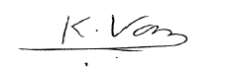

2.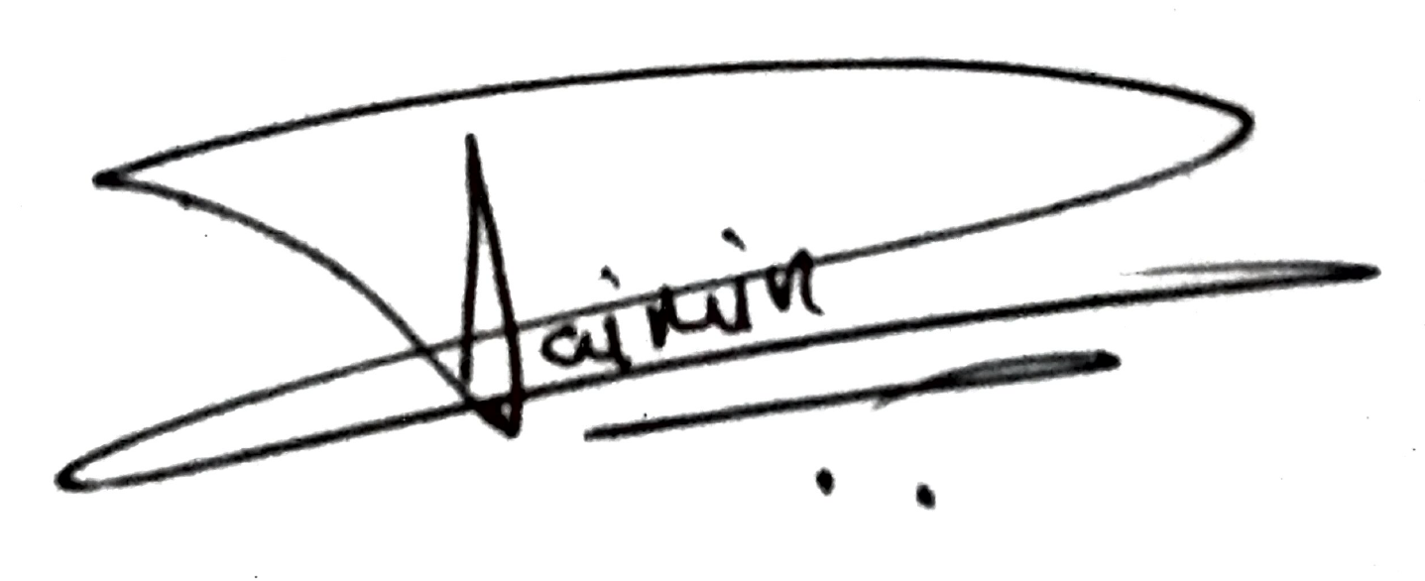

3.

4. 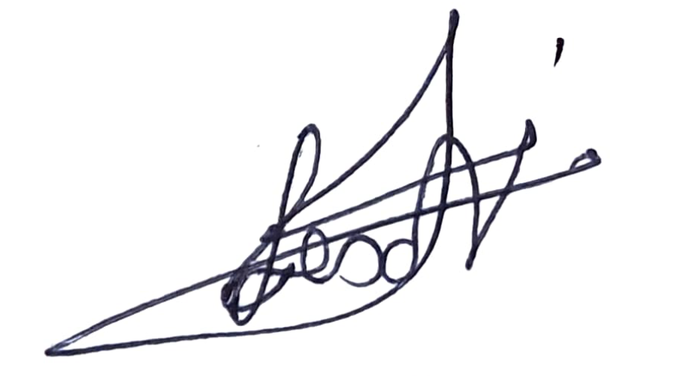

(Signature of Students)

# Letter of Acceptance

I undersigned, Prof. Dr. Kavita Sonawane working in Computer Engineering department, willing to guide the project titled Travel Destination Website for the mini project-I Semester III /IV respectively for the academic year 2020-21. The names of the students are:

1. Jaimin Solanki

2. Rohan Tondlekar

3. Keegan Vaz

4. Alex Victor

(Project Guide) (Mini Project Coordinator) (HOD Computer)

.

**SCHEDULE FOR MINI PROJECT**

|  |  |  |  |  |
| --- | --- | --- | --- | --- |
| **Date** | **Week** | **Content** | **Remark** | **Guide Sign** |
| 13/08/2020 | 1 | Explained about mini project: We were briefed about the project and what we were going to do in this subject in the whole sem. |  |  |
| 20/08/2020 | 2 | Group Division and Topic discussion |  |  |
| 27/08/2020 | 3 | Project Presentation |  |  |
| 03/09/2020 | 4 | Made the Use-case diagram for the project. |  |  |
| 10/09/2020 | 5 | Separated the destinations state-wise and collected data about them. |  |  |
| 17/09/2020 | 6 | Started creating main page of website. |  |  |
| 24/09/2020 | 7 | Did some minor changes in the main page. |  |  |
| 01/10/2020 | 8 | Created the review page. |  |  |
| 08/10/2020 | 9 | Designed the contact us page. |  |  |
| 15/10/2020 | 10 | Created the about us page and added information in it. |  |  |
| 22/10/2020 | 11 | Made the explore button contents. |  |  |
| 30/10/2020 | 12 | Guides allotted, final project discussion |  |  |
| 05/11/2020 | 13 | Updated the explore button contents. |  |  |
| 12/11/2020 | 14 | Added few famous tourist attractions to the website |  |  |
| 19/11/2020 | 15 | Integrated the Google Map API and Connected the database. |  |  |

**PROGRESS/ATTENDANCE REPORT**

|  |  |
| --- | --- |
| Title of the Project: Travel Destination Website | |
| Group No. B2 | Name of Student 1: Jaimin Solanki |
| Name of Student 2: Rohan Tondlekar |
| Name of Student 3: Keegan Vaz |
| Name of Student 4: Alex Victor |
| Name of the Supervisor: Dr. Kavita Sonawane | |

|  |  |  |  |  |  |  |  |  |  |
| --- | --- | --- | --- | --- | --- | --- | --- | --- | --- |
| Sr. No | Date | Attendance | | | | Progress/Suggestion | Mapping | | |
|  |  | 1 | 2 | 3 | 4 |  | CO | PO | PSO |
| 1 |  |  |  |  |  |  |  |  |  |
| 2 |  |  |  |  |  |  |  |  |  |
| 3 |  |  |  |  |  |  |  |  |  |
| 4 |  |  |  |  |  |  |  |  |  |
| 5 |  |  |  |  |  |  |  |  |  |
| 6 |  |  |  |  |  | Presentation 1 |  |  |  |
| 7 |  |  |  |  |  |  |  |  |  |
| 8 |  |  |  |  |  |  |  |  |  |
| 9 |  |  |  |  |  |  |  |  |  |
| 10 |  |  |  |  |  |  |  |  |  |
| 11 |  |  |  |  |  |  |  |  |  |
| 12 |  |  |  |  |  |  |  |  |  |

Sign of the Supervisor

# EXAMINER'S FEEDBACK FORM

Name of External examiner: College of External examiner: Name of Internal examiner:

Date of Examination: / / No. of students in project team: Availability of separate lab for the project: Yes / No

**Student Performance Analysis** (Put Tick as per your Observation)

|  |  |  |  |  |
| --- | --- | --- | --- | --- |
| Excellent (3) Very Good (2) Good (1) | | | | |
| **Sr. No.** | **Observation** | **(3)** | **(2)** | **(1)** |
| 1 | Quality of problem and Clarity |  |  |  |
| 2 | Innovativeness in solutions |  |  |  |
| 3 | Cost effectiveness and Societal impact |  |  |  |
| 4 | Full functioning of working model as per stated requirements |  |  |  |
| 5 | Effective use of skill sets |  |  |  |
| 6 | Effective use of standard engineering norms |  |  |  |
| 7 | Contribution of an individual’s as member or leader |  |  |  |
| 8 | Clarity in written and oral communication |  |  |  |
| 9 | Overall performance |  |  |  |

o Can same mini project extend to next semester by adding new objectives/ideas? (Yes/ ~~No~~)

o If yes, suggest new Innovative Technique/Idea/ objectives related to this project.

## Signature of External Examiner Signature of Internal Examiner